**JOINS IN SQL DATABASE**

Joins – word itself means to combine something, In SQL (where we play with lots of data and numbers), JOINS are used to combine data from multiple tables in [database](https://en.wikipedia.org/wiki/Database). These are primarily used when we want to extract data from tables which have [one-to-many](https://en.wikipedia.org/wiki/One-to-one_(data_model)) or [many-to-many](https://en.wikipedia.org/wiki/Many-to-many_(data_model)) relationships between them, And also if we want to retrieve data from more than one table through a select statement.

Now, we know what joins are, let us look what are the different types of joins we can practice in SQL

**Types of joints:**

1. Inner - join
2. Left - join
3. Right - join
4. Full outer - join
5. Cross - joins
6. Self – join

INNER – JOIN

This is the simple and most generally used join and hence also called **SIMPLE JOIN**. It selects records from the data that have matching values in both the tables. It compares each row of table A with each row of table B and vice-versa and then return the common records from the both the tables or we can say **INTERSECTION** of both the tables.

For example,

Consider the table_A and table_B for performing joins:

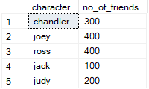 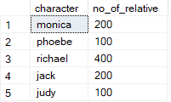

**table_A table_B**

**Syntax of INNER JOIN:**

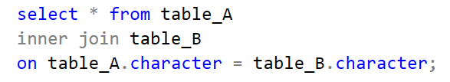

**Execution table or Result table:**

**only the data from common records of both the tables are reterive
 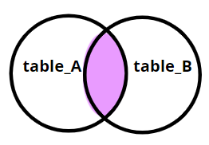**

LEFT – JOIN

This returns all the records from table A and the common records from both the table that is table A and table B (intersection of table A and table B), and will not return the records from table B which are not common.

**Syntax of LEFT JOIN:**

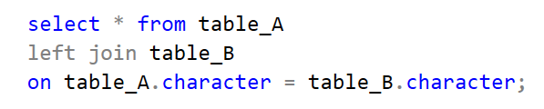

**Execution table or Result table:**

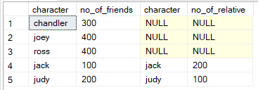 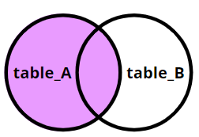

RIGHT – JOIN

This returns all the records from table B and the common records from both the tables that is table A and table B (intersection of table A and table B), and will not return the records from table A which are not common.

**Syntax of RIGHT JOIN:**

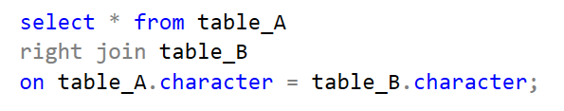

**Execution table or Result table:**

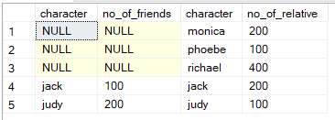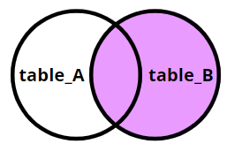

FULL OUTER – JOIN

This will return all the records from table A and table B, (doesn’t matter whether common values are there or not).

**Syntax of FULL JOIN:**

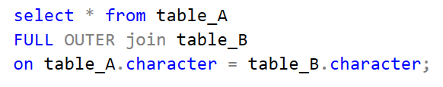

**Execution table or Result table:**

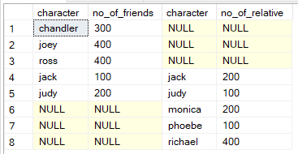 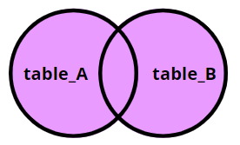

CROSS – JOIN

This join creates a [**CARTESIAN PRODUCT**](https://en.wikipedia.org/wiki/Cartesian_product)between two sets of data from the table A and table B, in CROSS JOIN each row of table A maps with each row of table B.

**Syntax of CROSS JOIN:**

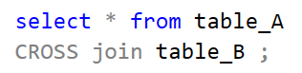

**Execution table or Result table:**

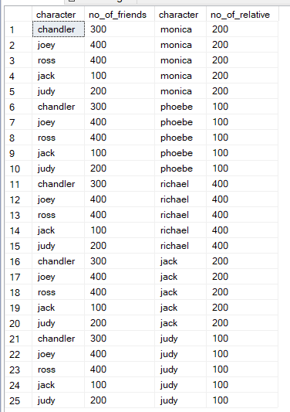 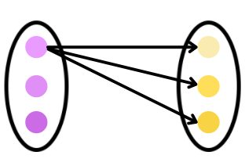

**table_A table_B**

SELF – JOIN

This join, joins the record of a table with itself and other records of the table are depending on the condition.

**Syntax of SELF JOIN:**

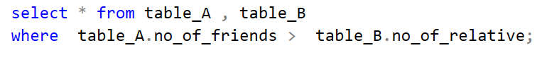

**Execution table or Result table:**

